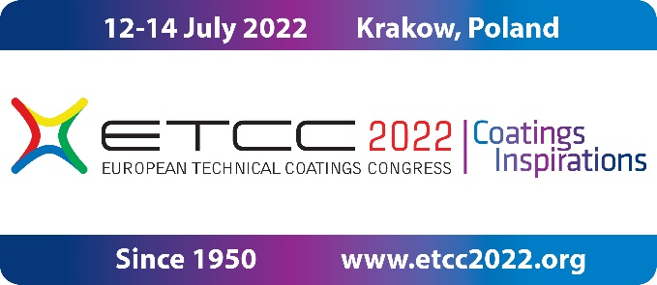

**CONGRESS ETCC2022. NEW DATE** **12–14 July 2022**

Due to the social and legal limitations caused by the SARS CoV-2 pandemic

**new date of the** **European Technical Coatings Congress ETCC2022**

***(****before ETCC2020***) is: 12 – 14 July 2022 in Krakow.**

The ETCC2022 presentations refer to the latest scientific and technical achievements concerning: **paints, coatings, raw materials, adhesives, construction materials, related processes and concepts.**

**New ABSTRACT SUBMISSION, deadline: 30 January 2022**

For more detailed information please visit: [www.etcc2022.org](http://www.etcc2022.org)

Some **ETCC2022 facts and figures**:

* We have 138 oral and 68 poster presentations accepted to be presented by 200 authors from many countries world-wide, please see the congress program at: [*www.etcc2022.org/en/congress/congress-program*](http://www.etcc2022.org/en/congress/congress-program%20%20%20%20))
* The possibility of publishing congress papers in renowned journals is arranged [*www.etcc2022.org/en/congress/publication-in-journals*](http://www.etcc2022.org/en/congress/publication-in-journals)
* Exhibition prepared, details available at:

[*www.etcc2022.org/en/congress/registration-form-for-exhibitors*](http://www.etcc2022.org/en/congress/registration-form-for-exhibitors)

* The “SummerSchool” program for young scientists is created, available at: [*www.etcc2022.org/en/congress/summer-school*](http://www.etcc2022.org/en/congress/summer-school%20%20)

During the three days of the event there will be **plenary presentations,** **6 parallel sessions, poster presentations, and an exhibition.**

Speakers are representing the largest companies, institutes, and universities from many countries world-wide.

All conditions, including:

* Registration for the congress
* Congress fees already paid
* Oral and poster presentations submitted
* Registration to the exhibition
* Registration to the “Summer School” session for young scientists

will be fully valid for the new congress date.

TheETCC2022 organisers of the are:

**FATIPEC** – Federation of Associations of Technicians for Industry of Paints in European Countries ([*www.fatipec.com*](http://www.fatipec.com) )

and

**SITPChem** – Polish Association of Chemical Engineers ([*www.sitpchem.org.pl*](http://www.sitpchem.org.pl) *)*

In case of questions please contact the Congress Organising Committee:

E-mail: [etcc2022@sitpchem.org.pl](mailto:etcc2022@sitpchem.org.pl)

Please follow us also in the social media:

[cid:08043348-4e5c-4c4b-a003-8f070f35ef47](https://www.facebook.com/etcc2020) [cid:59c84e39-427e-405e-9a91-a49bbc4886e2](https://www.linkedin.com/company/sitpchem-stowarzyszenie/) [](https://www.instagram.com/etcc2020/)

ETCC2022 Congress Organising Committee